
Deepfakes
Research Task
Watch 1-3 videos from the given list!
Write down information about deepfakes that you think is important (definitions, examples, how it works, risks, etc.)!

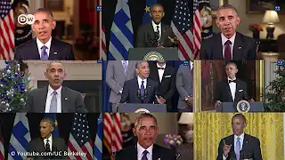 | How to detect deepfakes | Deepfakes explained (english)  Researchers explain their approach to detect deepfakes. | 
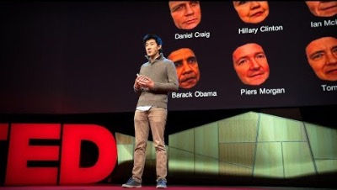 | Fake videos of real people - and how to spot them (english)  Do you think you are good at spotting fake videos where famous people say things they have never said in real life | 
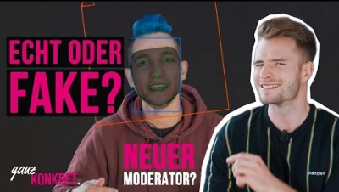 | ganz konkret: Deepfakes gegen Fakten? | Zeit für Politik (german)  This video is about how deepfakes work roughly and what possibilities you have with this technology. | 
 | Deepfakes: Is This Video Even Real? | NYT Opinion (english)  In the video, a fake news specialist responds to growing concerns about "deepfakes," seemingly realistic videos generated by artificial intelligence. | 
 | How Dangerous are Deepfakes? | Explained (english)  This video wants to show you a wide range of deepfakes—both dangerous and beneficial—and explain how they actually work. | 
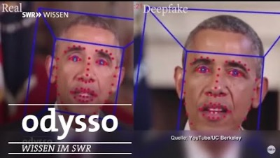 | Täuschung mit Deepfakes | Odysso – Wissen im SWR (german)  This video creates deepfakes and talks about how to detect deepfakes in the future. | 

